Sec 4 Chemistry Notes

Topic 1: Periodic Table
- Arrangement of Elements:
- Definition: The periodic table is an arrangement and classification of the elements that can be used to predict the properties of elements
- Ordered in increasing proton (atomic) number
- Horizontal rows are periods, vertical columns are groups
- Across a period, metals → metalloids → non-metals
- Metalloids have properties of metals and non-metals

- Periods & Groups
- Period number = number of electron shells
- Group number = number of valence electrons (Except for Helium → 2 valence e-)
- Elements in the same group exhibit similar chemical properties because they have the same number of valence electrons which are involved in chemical reactions

- Group I Elements - Alkali Metals
- Physical properties:
  - Soft, shiny and silvery
  - Cut easily with razor blades
  - Reacts rapidly with oxygen and water in air
  - Kept under oil to prevent tarnishes
  - Low densities (Li, Na, K float on water)
  - Low melting and boiling points:
Explanation:
  - Down Group I, size of cations increase while charge remains the same.
  - electrostatic attraction between metal cations and “sea” of delocalised mobile electrons gets weaker
  - Less energy required to overcome these forces of attraction
  - melting/boiling point of elements decreases

- Chemical properties:
  - Most reactive & electropositive metals
Electropositivity measures element’s ability to donate electrons (opposite of electronegativity)
  - Reaction with water:
Group I metal (M) + water → alkaline metal hydroxide + hydrogen gas
2M + 2H₂O → 2MOH + H₂
  - Reactivity increases down Group I:
- Alkali metals are electropositive and react by losing their one valence electron
Explanation:
- Down Group I, size of atoms increases
- Electrostatic attraction between nucleus and the valence electron get weaker
- Easier for each metal atom to lose its valence electron to form a positively-charged ion
- Reactivity of elements increases
- Reducing power increases as they become better electron donors (optional, state if question asks)

- Summary for Group I metals

Down the group ↓ | Melting & boiling points ↓ | Density  GENERALLY ↑ | Reactivity ↑ | Reducing power ↑

- Group VII Elements - Halogens
- Physical Properties
  - Down the group, colour deepens

Halogen | Colour of element | Colour in
 |  | Aqueous Solution | Hexane
Fluorine F₂ | Pale yellow gas | Colourless | Colourless
Chlorine Cl₂ | Greenish yellow gas | Pale yellow | Pale yellow
Bromide Br₂ | Reddish brown liquid/gas | Orange | Reddish brown
Iodine I₂ | Black solid / purple gas | Brown | Purple

  - Exist as diatomic molecules
  - Low densities - increases down the group
  - Down the group, melting & boiling points increase
Halogens have simple covalent structure, exist as discrete (individual) molecules → weak intermolecular forces of attraction between halogens molecules

Explanation:
- Down Group VII, the molecular mass increases
- Intermolecular forces of attraction between the halogen molecules get stronger
- More energy is required to overcome the stronger intermolecular forces of attraction
- Melting and boiling points increase

- Chemical Properties
  - Most reactive non-metals, as they are highly electronegative
  - Reactivity decreases down Group VII
Halogens react by gaining one or more valence electrons to form halide anions X⁻
Explanation:
- Down Group VII, size of atom increases
- Electrostatic attraction between the nucleus and the electron to be added to the valence shell get weaker
- Harder for the halogen atom to attract an electron to form a negatively-charged ion X⁻
- Reactivity of elements decreases
- Oxidising power also decreases as they become worse electron acceptors (optional, state if question asks)
  - Displacement reaction:
A more reactive halogen can displace a less reactive halogen from its salt
Cl₂ (g) + 2KI (aq) → 2KCl (aq) + I₂ (aq)
Greenish-yellow colourless colourless brown
Observations:
The colourless KI (aq) turns brown. Some black I₂ solid is also formed
Explanation:
Cl being more reactive than I, displaces less reactive I from colourless
solution KI to form colourless solution KCl and brown I₂.
(A brown solution is formed when black solid iodine dissolves in water,
excess solid iodine that does not dissolve remains as a black solid.)

- Summary for Halogens

Down the group ↓ | Melting & boiling points $↑$ | Colour becomes darker | Reactivity ↓ | Oxidising power ↓

- Group VIII Elements - Noble gases
- Least reactive elements in the Periodic Table (also once known as inert gases)
- Exist at monatomic molecules (free atoms, not bonded to other atoms)
- They are very stable because of their stable octet or duplet electronic configuration
- They make < 1% of air (rare gases, and obtained through fractional distillation of liquified air)

Element | Use | Reason
Helium | - Fill airships & weather balloons | - Low density
Neon | - Neon lights for advertisement signboards | - Gives red glow when electric current passes through
Argon | - Fill light bulbs  - Provide inert atmosphere for certain purposes such as welding stainless steel | - Unreactive and helps to protect filament  - Inert and protects weld from atmospheric contaminants

- Transition Elements / Metals
- Found between Group II and Group III
- They and their compounds are important catalysts for many reactions, both in the lab and industry.
- Iron - Used in Haber process to manufacture ammonia
- Nickel - Manufacture of margarine from vegetable oil
- Properties:
  - High melting and boiling point
    - There is strong electrostatic attraction between the positively charged metal cations and the delocalised mobile valence electrons
  - High density
    - Denser than group I and II metals as atoms are more tightly packed together (due to strong metallic bonds)
  - Variable oxidation states in their compounds
    - Have ability to form compounds in a range of oxidation states
  - Form coloured compounds
    - Aq iron(II) chloride is green, Aq iron(III) chloride is yellow
    - Colours of compounds are different with different oxidation states
    - Can be used in dyes, pigments and stained glass to produce different colours

Common Substances and their colours:
  - Solids
    - Blue: Copper salts
    - Green: Iron(II) salts, Copper Carbonate
    - Red-Brown: Iron(III) salts
    - Black: Copper oxide, Iodine
    - Yellow: Silver Iodide, Lead(II) Iodide
    - Pink: Copper metal
    - Purple: KMnO₄
    - Orange: K₂Cr₂O₇
  - If you still don’t know the colour, it is most probably white
  - Liquids/Solutions
    - Blue: Copper salts
    - Green: Iron(II) salts
    - Yellow: Iron(III) salts
    - Purple: KMnO₄
    - Orange: K₂Cr₂O₇
  - If you still don’t know the colour, it is most probably colourless

Topic 2: Metals
- Metals are found mainly in Groups I, II, III and d-block (contains transition metals) of the Periodic Table
- Electropositive in nature (they tend to lose their valence electrons to form a sea of delocalised mobile valence electrons)
- Metallic bond refers to the electrostatic attraction between the negatively-charged delocalised mobile valence electrons and the positively-charged metal cations
- Physical properties:

Property | Structural Attribute
High melting & boiling points  (except for mercury & alkali metals) | Strong electrostatic attraction forces between delocalised mobile valence electrons and the metal cations
malleable | Layers of atoms (or cations) can slide over one another when a force is applied
Good conductor of heat | Delocalised valence electrons help to transfer heat
Good conductor of electricity | Delocalised mobile valence electrons can move freely through the circuit when a potential difference is applied

- Alloys:
  - It is a mixture of metal (eg iron) with other elements which can be metals (eg nickel/chromium) or non-metals (eg carbon). The properties of a metal can be improved if mixed with other elements
  - Pure metals are usually soft and weak as the positively-charged cations are of the same size and arranged in an orderly manner. Hence, layers of cations can slide over each other easily
  - Alloys are much stronger as additional metal / non-metal atoms of a different size disrupt this orderly arrangement, making it difficult for the layers of cations to slide over one another
  - Special properties of alloys which the constituent metal / non-metals do not possess:

Alloy | Constituents | Uses | Property
steel | Iron, carbon, various other elements | Bridges, car bodies, railways | Stronger than pure iron
bronze | Copper, tin | Medals, swords, statues | Hard, corrosion resistant
brass | Copper, zinc | Ornaments, electrical wiring and contacts | Hard, corrosion resistant

- Reactivity Series:
  - A list of metals with the most reactive metal places at the top and the least reactive metal placed at the bottom
  - Reactivity of a metal is related to its tendency to form a positively-charged ion. Greater tendency, more reactive
  - The order of reactivity is deduced from the reactions of
- Metals with water (and steam)
- Metals with dilute hydrochloric acid
- Oxides of metals with carbon and hydrogen
- Metals with the aqueous ions of other metals
- Metals with the oxides of other metals

Reactivity Series of Metals (Mnemonic)
Potassium  Sodium  Calcium  Magnesium  Zinc  Iron  Lead  *hydrogen  Copper  Silver  gold | Please  Send  Cats  Monkeys  Zebras  In  Large  *hired  Cages  Safely  Guarded | Please  Stop  Calling  Me  Zebra  I  Love  Happy  Cats  Silver &  Gold

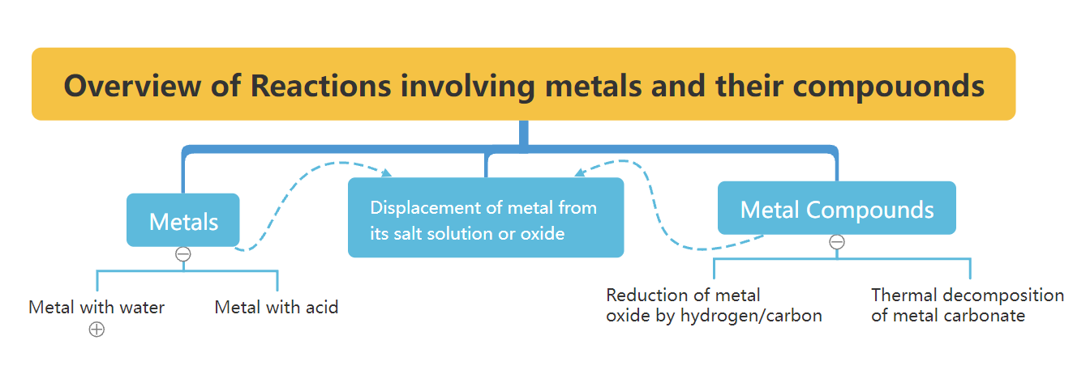

- Reactions of Metals with water:
  - The more reactive metals (K, Na, Ca, Mg - very slowly) can react with cold water to produce a metal hydroxide and hydrogen gas
  - The less reactive metals (Mg, Zn, Fe) cannot react with cold water but will react with steam when heated to produce a metal hydroxide and hydrogen gas
- Reactions of Metals with Dilute Hydrochloric Acid
  - Metals below lead (Pb) in the reactivity series have no reaction with dilute hydrochloric acid
- Reduction of Metal Oxides by Hydrogen or Carbon
  - CuO (s) + H₂ (g) → Cu (s) + H₂O (g)
  - 2CuO (s) + C (s) → 2Cu (s) + CO₂ (g)
  - Carbon is used more often compared to hydrogen because
    - Cheaper
    - More effective
  - The more reactive the metal, the more difficult to reduce it using H₂ / C

Oxide of | Action of Hydrogen | Action of Carbon
potassium | No reaction | No reaction unless oxides heated to about 2200 ºC
sodium
calcium
magnesium
zinc |  | Reduced to metal at high temp at least 600 ºC  (with increasing ease)
iron | Reduced to metal at high temp at least 800 ºC  (with increasing ease)
lead
copper
silver

- Displacement Reactions of Metals
  - A more reactive metal will displace a less reactive metal from a solution of its salt
  - Full equation: Mg (s) + CuSO₄ (aq) → MgSO₄ (aq) + Cu (s)
  - Ionic equation: Mg (s) + Cu²⁺ (aq) → Mg²⁺ (aq) + Cu (s)
  - More reactive Mg displaces less reactive Cu from blue solution CuSO₄ to form colourless solution MgSO₄ and reddish-brown/pink solid Cu.
  - For the metals deposited, they tend to be grey in colour other than:
    - Copper, Cu metal is pink/reddish-brown
    - Silver, Ag metal is silvery
  - A more reactive metal will displace a less reactive metal from its oxide
  - Zn (s) + CuO (s) → ZnO (s) + Cu (s)
  - The more reactive Zn displaces less reactive Cu from black CuO to form white solid ZnO and pink solid Cu.
- Thermal Stability of Metal Carbonates
  - Thermal stability describes how easily a compound will decompose upon heating
  - Increased thermal stability means a higher temperature is required to decompose the compound
  - More reactive metals form compound that are more stable to heat

Metal | Metal Carbonate
potassium | Stable to heat (do not decompose) with Bunsen burner
sodium
calcium | Decompose under heating to form metal oxide and carbon dioxide  CuCO₃ (s) → CuO (s) + CO₂ (g)
magnesium
zinc
iron
lead
copper
silver | Decomposes on heating to form the metal

- Extraction of Metals
  - Only unreactive metals like Ag and Au are found naturally as pure metals
  - For most metals, they are found in the form of metal ores and the more reactive the metal, the more difficult it is to extract from its metal ore
  - This is because the more reactive metals tend to form more stable compounds

Metal | Extraction Method
potassium | Electrolysis of molten ore  Metal is deposited on cathode
sodium
calcium
magnesium
zinc | Heating ore with carbon
iron
lead
copper | Roasting ore by heating alone
Silver and gold | Can be found as pure metal

- Extraction of Iron
  - Look on SLS for extraction of Iron: https://vle.learning.moe.edu.sg/mrv/assignment/attempt/aeb6943e-2ce2-42a3-b4e2-02bb9d4ba99a/page/38093591
- Rusting of Iron
  - Rust is the reddish-brown solid that appears on the surface of iron and steel
  - Mainly hydrated iron(III) oxide:
    - 4Fe (s) + 3O₂ (g) + xH₂O (l) → 2Fe₂O₃.xH₂O (s)
  - Formed via redox reaction
    - Fe → Fe³⁺ + 3e– (loss of electrons)
    - O₂ + 4e– → 2O²⁻ (gain electrons)
  - Rust is a flaky coating which peels off and this allows the iron underneath to rust further. This weakens the structure that is made of iron
  - Other metals also react with oxygen but not in the same way. These reactions cannot be termed as “rusting”.
  - Conditions for rusting
    - Both oxygen and water are needed for rusting to occur
- Prevention of rusting
  - Surface (or barrier) protection
- Painting - Carried out to protect large iron and steel structures like bridges or ships
- Greasing - Thin films of grease/oil used to protect moving parts like machines and bicycle chains
- Coating
  - Tin - Coating the entire surface with tin prevents rusting. However, if tin layer is scratched, iron underneath it rusts more rapidly than it normally would as iron is more reactive than tin
  - Plastic - Small iron and steel objects are often covered with a thin layer of plastic E.g. wires, metal clips and chair legs
- Electroplating - Electroplated with precious metals like silver, gold which are unreactive
  - Sacrificial protection (using a more reactive metal than iron)
    - Galvanising
      - Coating object with protective layer of zinc metal
      - Even if zinc is scratched, zinc will be preferentially oxidised to iron
      - Cheap and used for outdoor appliances e.g. dustbins, handles
    - Attaching a more reactive metal
      - More reactive Mg is preferentially oxidised, slowing down the rusting of Fe by providing sacrificial protection
      - Used for underground objects like tanks or gas pipes
  - Use of stainless steel
    - Alloy of iron that consists at least 10.5% chromium
    - Chromium in alloy reacts with oxygen to form a thin protective oxide layer
    - Hence it is resistant to corrosion
- Recycling of Metals
  - Please refer back to your notes because at this point it would probably just be copying and pasting (page 2-16)

Topic 3: Electrolysis
Introduction:
- Conductor:
- Electrical conductor
    - Allows the flow of electrical current
    - Conduction by movement of electrons
    - Not chemically changed
E.g. All metallic elements and alloys + graphite
  - Electrolytic conductor
    - Allow the flow of electrical current
    - Conduction by ions
    - It is decomposed
E.g. Ionic compounds in molten
Some covalent compounds in aqueous states (acids)
- Non-conductor
  - No electrical current flowing
E.g. non-metallic, covalent compounds, ionic compounds in solid state

Strength of electrolytes:
- Strong: high concentration of mobile ions: strong acids, strong alkali, salts, higher current
- Weak: low concentration of mobile ions: weak acids, weak alkali, lower current

Electrolysis:
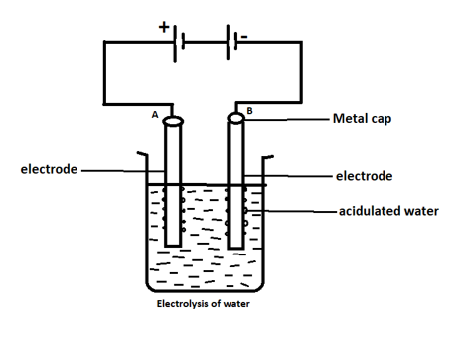
- Process of using electricity to break down/decompose a compound
- Battery acts as a pump to draw electrons from anode and to cathode
- Anode is where oxidation occurs, connected to positive terminal (an ox)
- Cathode is where reduction occurs, connected to the negative terminal (Red Cat)

Types of electrolysis:
- Molten electrolysis
  - Contains only their constituent ions

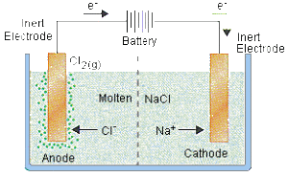

 | Anode | Cathode
Species Present | Cl⁻ (l) | Na⁺ (l)
Ionic equation | 2Cl⁻ (l) → 2e- + Cl₂ (g) | Na⁺ (l) + e- → Na (s)
Overall reaction | 2NaCl (l) → Cl₂ (g) + 2Na (s)
*Note that electrode used are graphite

Aqueous electrode
- Aqueous solution (electrolyte), large proportion consists of water molecules
- Ions and water molecules compete for reaction (preferential oxidation/reduction)
- 3 factors that affect preferential oxidation:
  - Position of species in redox series (least impt)
  - Concentration of chemical species in electrolyte
  - Nature of electrode (most impt)

- Factor 1: Position of species in redox series

Anions | Cations
SO₄²⁻ | K⁺
NO₃⁻ | Ca⁺
Cl⁻ (Factor 2) | Na⁺
(H₂O) | Mg²⁺
Br⁻ | (H₂O)
I⁻ | Zn²⁺
OH⁻ | Fe²⁺
 | Pb²⁺
 | H⁺
 | Cu²⁺
 | Ag⁺
*Ease of oxidation/reduction increases down the table

- Electrolysis of H₂SO₄ (aq)
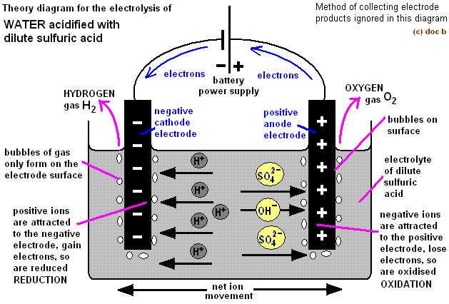

 | Anode | Cathode
Species Present | H₂O (l), SO₄²⁻ (aq) | H₂O (l), H⁺ (aq)
Observations | Colourless gas evolved that relights a glowing splint | Colourless gas evolved that extinguishes a lighted splint with a pop
Ionic equation | 2H₂O (l) → O₂ (g) + 4H⁺ (aq) + 4e- | 2H⁺ (aq) + 2e- → H₂ (g)
Overall reaction | 2H₂O (l) → O₂ (g) + 2H₂ (g)
*Anions, H₂O (l) preferentialy oxidised
*Cations, H⁺ (aq) preferentially reduced
*Concentration of acid increases since volume of water to acid decreases
*Volume of H₂ : Volume of O₂ = 2:1

Gg, this mentor forgot to do the online one so here is the hardcopy: (managed to finish factor 1 TT)
